**Aimee Shoun**

**The Proposal**

**Game objectives:**

1. **The rat has some cheese that he needs to take to his family down in the sewer.**A picture containing dark

   Description automatically generated

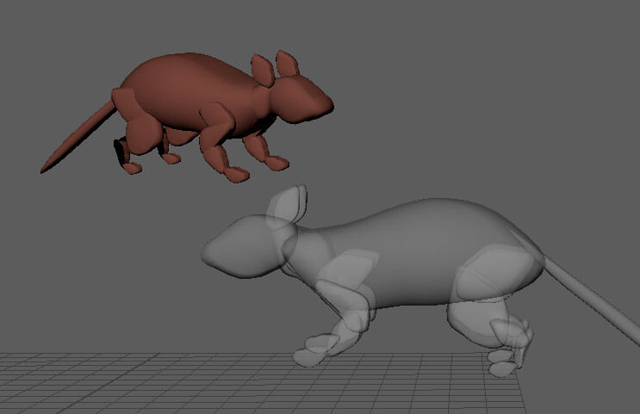

1. **There is a spider robot called “Spyder” that has one job, to search and destroy rats.**

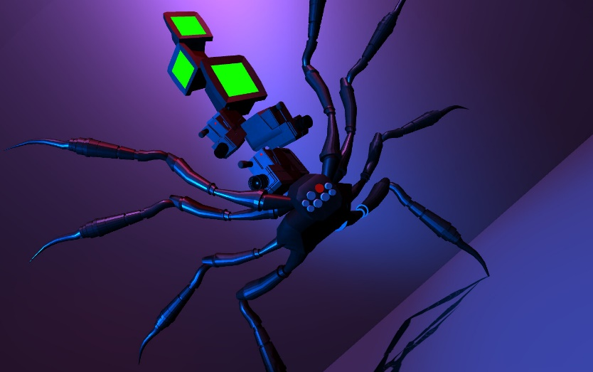

1. **The rat will access the sewer through a dingy old non-functioning toilet.**A picture containing wall, indoor, toilet, white

   Description automatically generatedDiagram

   Description automatically generatedA picture containing indoor, toilet, white

   Description automatically generated
2. **The toilet will lead to the pipe MAZE below.**

1. **The rat must find his family by going through the maze pipes.**

1. **There will be toxic sludge that will deplete his health as well as aggressive roaches.**

1. **He can raise his health by eating the regular roaches by catching them.**

Video of rig: https://youtu.be/Mj0vWxLp6cM

1. **There will be toxic roaches that glow green. If he eat these he will gain faster abilities and glow green for a limited time.**
2. **He has to get to his family with the cheese before the “Spyder” finds him and kills him.**

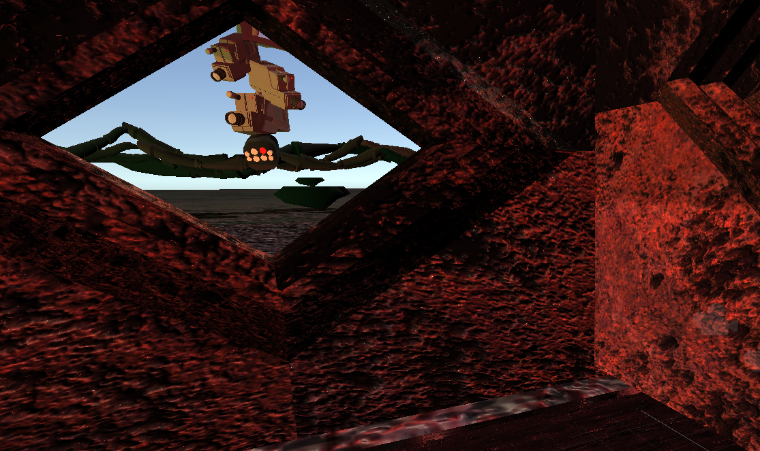

1. **Once he finds his family the game is over.**
2. **Every time he dies he will spawn back to the bathroom and start over.**